**Policy Video Script**

|  |  |
| --- | --- |
| **Speech** | **Image** |
| To fight climate change and avoid an ever-warming climate, we need an array of policies, | Curve of temperature is rising, then an item appears and blocks its further increase, then the curve continue to be drawn but flat. This item is a barred red circle inside of which there is a plane and a car with smoke/pollution. |
| to transform the way we produce energy, to have greener buildings and greener cars, to reduce our fuel consumption, and to protect people’s jobs and incomes. Let’s have a closer look on three possible climate policies. | Each corresponding item appears when its name is pronounced: a windpanel below a crane, a barred red circle with polluting car, a person with a gallon of oil in one hand and cash in the other where size of gallon diminishes and cash grows. |
| Let’s start with the policy which already exists [*US*: or almost] in [*non-India:* [Our country] / *India*: many countries][1]: an emission standard for cars. | Shows a map of country’s region where the country is in green and neighbors in grey |
| With [*non-US/India:* this / *US, India:* an] emission standard, car producers are required by law to limit the average emission of CO2/km of the vehicles they sell in a year [*US:* or, as is the case in the US, the fuel economy in Miles-Per-Gallon]. The [*non-US:* emission limit is lowered / *US:* minimum fuel economy is increased] every year, with the aim that only electric or hydrogen vehicles will be sold after 2040**[2]**. | Show a car with smoke/pollution next to a factory, then a bill of law with **“max 95 gCO2/km [\newline] 2021”**[3] written, then the smoke diminishes, then the text becomes “max 60 gCO2/km [\newline] 2030” and the smoke diminishes further, then “only electric [\newline] 2040”[4], the smoke disappears and an electric plug appears on the car |
| Together with a plan to produce electricity from carbon-free and renewable sources, emission standard would accomplish the transition needed in the car industry. | The electric car, a sign “+” and wind panels, a sign “=” and a thumb up |
| ~~Oh, and [~~*~~non-India~~*~~: our country is not alone to reduce the emissions from its cars: every big economy has a similar plan! /~~ *~~India~~*~~: our country actually has a similar plan, as every big economy!]~~ | ~~A world map with the EU, China, India, Norway in green and the other in grey~~ |
| Now, let’s turn to the policy advocated by 28 Nobel prizes: a carbon tax with compensation. | Shows the person with a gallon of oil in one hand and cash in the other where size of gallon diminishes and cash grows, then put a square academic cap on top of her. |
| With a carbon tax, all products that emit greenhouse gases would be taxed. For example, the price of gasoline would increase **by [xxx %][5].** | A person fills up her gas tank. The price of gasoline is displayed, and it goes up. |
| With a carbon tax, polluting firms and people pay for their greenhouse gases emissions, which pushes them to reduce their emissions. | The person walk away from her car and takes a bicycle. |
| To compensate people for the price increases, the revenues of the carbon tax would be rebated to all households, regardless of their income. Each adult would thus **receive [xxx] per year[6]**. | Shows a balance with on one side two barrels of oil and on the other side a pile of cash. **“+ $100”[7]** appears within each barrel so the balance tilts on the barrel side, then new cash comes on the pile with **“+$200”[8]** above and the balance tilts very slightly towards cash [figures to be adjusted]. Next to the balance is a normal person (e.g. woman in a dress). |
| On average, poor people have smaller cars, smaller houses and fly less, so they use less fossil fuels than average. As they would receive the same compensation as others, poor people will generally gain from a carbon tax with compensation. The converse is true for rich people. | The person is now a blue collar. Shows the same balance as before with one less barrel: now the balance clearly tilts towards cash. |
| Does this policy really work? Yes! Canada has enacted a carbon tax with compensation in 2018. Research has shown that this policy has decreased greenhouse gases emissions, increased employment, and that a majority of people has gotten more money in their pockets through the reform. | Shows a map of Canada with inside a car with diminishing polluting, 3 blue collars holding cash that turn 4 then 5 blue collars holding more cash (they don’t smile) |
| Although 60% of the population were skeptical of the carbon tax with compensation policy before it was enacted, now 60% supports the policy. | The blue collars now smile |
| Last but not least, a climate pact is a large program of public investment in green infrastructure, | Shows a windpanel below a crane. |
| which would be financed by additional debt taken up by the government. | Shows cash transiting from a bank and the government coffers to the windpanel/crane. |
| A climate pact would bring about the transition in energy infrastructure needed to halt climate change. In [our country], **xxx million of people would find a job[9]** in the green sectors: public transportation, renewable power plants, thermal renovation of building, sustainable agriculture, etc. | Show a blue collar next to the windpanel, then also a person in a bus, then also a construction worker near a building, then also a farmer in a field. |
| Re-training options would be offered to workers in polluting sectors such as coal mining, to ensure that they can find a new job too. | Shows a coal miner next to the other (but a bit farther away), his helmet switches from mining helmet (with lamp) to construction site helmet and his pick-axe switches to a hammer. (i.e. the coal miner becomes a construction worker) |
| In general, all climate policies have the potential to transform the economy and to replace polluting equipment and polluting behaviour by clean equipment and green behaviour. This implies some costs: people will have to change their habits, some people will even have to change of job. | Shows a factory / coal power plant, a polluting car and a coal miner, then an arrow, then a windpanel, a bicycle and a construction worker. |
| But this also comes with benefits: a safer world for future generations of course, but also less pollution, and climate policies can be designed to benefit poorer households, as they can have more income with the carbon tax with compensation, or more jobs with a climate pact. | On the right side of the arrow, add several blue collars holding cash. |
| We have just focused on three important climate policies, but many others would be useful to fight climate change. We can cite for example the funding of green innovation, subsidies for thermal insulation of buildings, or measures against deforestation. And to stop climate change, we probably need all of them together. | Shows a green light bulb, construction to repair a roof, and a growing tree. |

**Climate Video Script**

|  |  |
| --- | --- |
| **Speech** | **Image** |
| In the past decades, humans have been emitting more and more fossil fuels like coal, gas or oil. Burning fossil fuels releases CO2 in the atmosphere. | Graph (if possible, animated) of historic CO2 concentration, next to polluting cars (cars with smoke), planes, and coal power plants / factories (e.g. using <https://www.temperaturerecord.org/> ) |
| Today, the concentration of CO2 in the atmosphere is higher than any time over the last 800,000 years. | Unzoom to show graph of concentration over 800,000 years |
| And it’s the concentration of greenhouse gases like CO2 that drives global temperature. | Show graph of temperatures (e.g. using <https://www.temperaturerecord.org/> ) |
| Climate scientists agree: the build-up in the atmosphere of greenhouse gases released by human activity causes climate change. |  |
| A rapid transition away from fossil fuels is technically possible and could contain global warming below +2°C. | Extends graph of temperatures with 2°C scenario (e.g. using the figure below), and some windpanels and trees on the side |
| But if greenhouse gas emissions continue on their current trend, the average global warming will be +4°C in 2100 and +7°C in 2200. | Keep previous graph but adds a +4°C scenario (e.g. using the figure below), and on the side now there is a polluting car and a coal power plant / factory |
| This may seem far away, but the air pollution generated by the burning of fuels is already responsible for 6 million deaths each year, and we can already feel the climate change consequences as heat waves, droughts and other disasters intensify. | Shows a skull with “6,000,000”, then a desert with a shrub drying. |
| Here are some impacts expected by scientists in the absence of ambitious action climate change: | The thermometer rises between 3 and 4°C (color red) |
| * there would be more frequent and more severe natural disasters such as hurricanes, heat waves, droughts, floods, or forest fires | A hurricane, a drought, and a fire appear when there names are pronounced |
| * by 2070, one third of the global population could have to migrate towards places where the temperature remains suited for humans | Shows a family with suitcase, leaving there house in the middle of the desert, under a bright sun |
| * by 2100, sea-level rise would flood the houses of nearly 300 million more people each year | Shows a house near a beach, the sea-level rises (shrinking the size of the beach), then a waves comes and floods the house |
| * crop yields would decrease in most regions | Shows a banana tree with bananas on it (or any other crop), and some bananas dry up or disappear |
| * a large proportion of species and ecosystems would face an increased risk of extinction (for example, half of the Amazon rainforest could be replaced by savanna by 2100) | Shows a tropical forest (for example a few trees with a bird and a snake) that dries up, the trees lose their leaves, some fall, and the bird also falls dead |
| On average, each [person from our country] emits xxx[10] tons of CO2 per year, which is [xxx times][11] the world average. | A person from [our country] (i.e. a little man with the corresponding flag) with a polluting car [or without?], the size of the pollution clouds proportional to the emission, and within the cloud the amount is written (e.g. “18t”), and next to that the Earth with a pollution cloud (of size corresponding to 4.4t) |
| To tackle climate change, we would need to bring these emissions close to zero. This is possible, but requires a deep transformation in the sectors most responsible for greenhouse gas emissions: energy, transport, and industry. | Shows the second figure below. |

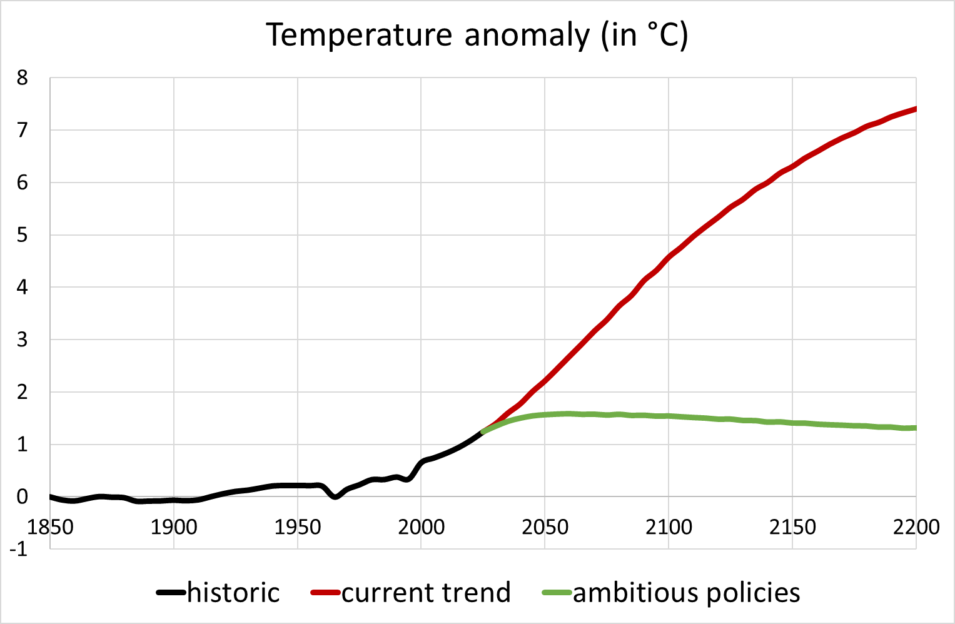

Source: Meinshausen et al. (2011) https://link.springer.com/article/10.1007/s10584-011-0156-z

There is also a version of this graph in French and in °F

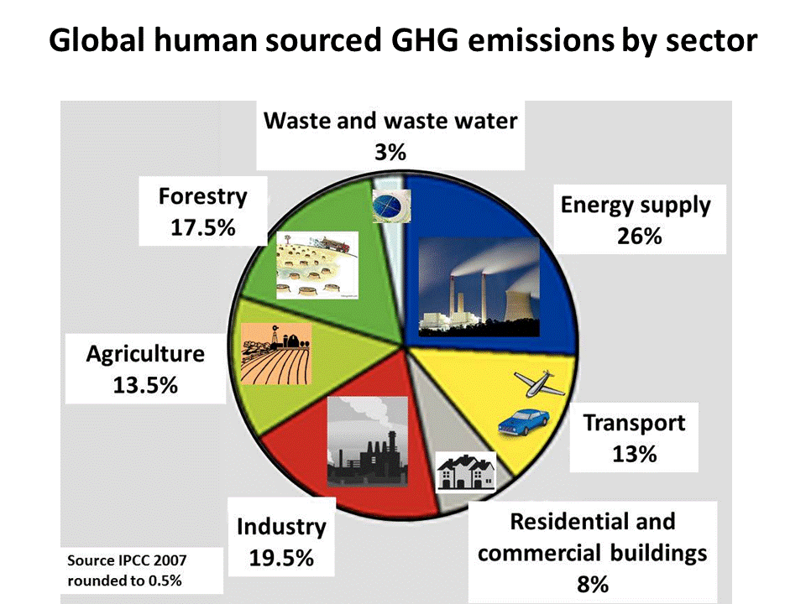

Source: https://i.pinimg.com/originals/28/f0/72/28f07273a64c12a313c3ad49ab8e5bae.gif

1. Doesn’t exist in India, Brazil, though India has announced it will ban sell of thermal cars in 2030 if they are cost-effective.
2. EU: target of 95 gCO2/km in 2021, 60g/km in 2030.

   USA: no limit on CO2 but constraint on fuel economy: e.g. 61 MPG in 2025 for small cars. Biden plans to “developing rigorous new fuel economy standards aimed at ensuring 100% of new sales for light- and medium-duty vehicles will be electrified”. California: ban sell of thermal cars in 2035. Actually Trump has rollbacked the CAFE standard, so the above figures are outdated.

   France, UK: have announced (but no law) ban sell of thermal cars in 2040.
3. Keep this figure for all EU countries (and the UK). For the US, replace it by: “min 50 MPG [\newline] 2021”.
4. Keep this figure for all EU countries (and the UK). For the US, replace it by: “min 60 MPG [\newline] 2025”.
5. In France : 10 centimes par litre (essence), cf. Douenne & Fabre (2020), for 45€/t.

   US : 40 cents per gallon (gasoline), cf. Marron & Maag (2018), assuming $45/t carbon tax

   India: 8 Rs/L. (7.80 rounded).
6. France: 100€/an (Douenne & Fabre, 2020). This is assuming that carbon tax is actually a fuel tax, applying only to gasoline, diesel, domestic fuel and domestic gas. US: $600/year (for a comprehensive $45/t carbon tax). For India, we take 2017 fossil [CO2 emissions](https://en.wikipedia.org/wiki/List_of_countries_by_carbon_dioxide_emissions), ([conservatively](https://link.springer.com/article/10.1007/s10784-011-9157-7)) assume the same emission reduction as in the US (19.6%: [5.1 => 4.1](https://media.rff.org/documents/RFF-IB-18-07-rev_4evu2ny.pdf)) (it yields 1.974Gt) and divide by the [adult population](https://www.cia.gov/library/publications/the-world-factbook/geos/in.html): 907.459M, i.e. $78/adult = 5761 Rs ($81=6000Rs). for a $45/t of which (as in US) $36/t can be rebated in a dividend and the rest compensates decrease in other tax revenues.
7. France: +50€. US: +$300. Given the volume of a barrel, its price would increase only by $20 with the amount of tax chosen. I think this is OK because the barrel here is purely illustrative, and the voice states the actual price increase.
8. France: +100€. US: +$600.
9. US : 1.5 million. Europe : 1.5 million. India: 5 million. China: 3 million. (direct net job creation w.t.r to baseline, Greenpeace, 2015)

   US : 1,9 million. France: 330k. Germany: 760k. UK: 410k. Brazil: 620k. India: 2.3 million. China: 9 million. (direct net job creation, Jacobson et al., 2017)

   France: 630k (Quirion, 2013).

   **Use the minimum of all available estimates to be conservative, i.e. 1.5 million in the US, 330 thousands in France, etc.**
10. US: 18 ; France: 7 ; India: 1.5 ; World: 4.4 https://stats.oecd.org/Index.aspx?DataSetCode=IO_GHG_2019
11. US: 4 times more ; France: 60% more ; India: 3 times less